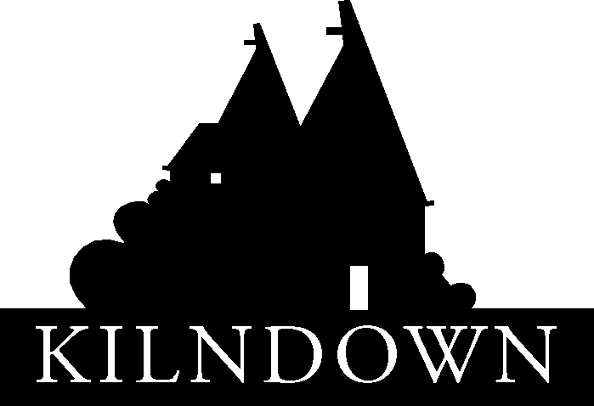

KILNDOWN ANNUAL PARISH MEETING

Thursday 21 April 2022, 7.30 for 7.45pm in Kilndown Village Hall

AGENDA

A prayer for Kent.

Welcome from the Chairman of Goudhurst Parish Council, Cllr Antony Harris.

Apologies for absence.

Report from Borough Cllr David Knight.

Reports from Village Organisations;
- Christ Church
- Goudhurst & Kilndown Local History Society
- Kilndown Community Choir
- Kilndown Educational Trust
- Kilndown Gardening Club
- Kilndown Quarry Centre
- Kilndown Village Hall & Millennium Green Trust

An update on Broadband in the Parish from Cllr David Knight.

Report on Goudhurst Parish Council activities from Cllr Antony Harris.

Goudhurst Parish Council: Questions for the Parish Council.

Every English parish must hold a parish meeting which must assemble annually between 1st March and 1st June (Local Government Act 1972). Although it is convened by the Parish Council with the Chairman of the Parish Council presiding, the Annual Parish Meeting is not a Parish Council meeting. It is a meeting of local government electors registered for the area in which it is held. Although the legal requirement is for one parish meeting to be held, by custom and practice meetings are held at both Goudhurst and Kilndown.

