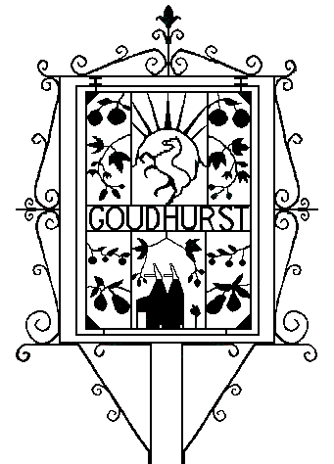

GOUDHURST ANNUAL PARISH MEETING

Tuesday 05 April 2022, 7.15 for 7.30pm in Goudhurst Village Hall

AGENDA

A prayer for Kent.

Welcome from the Chairman of Goudhurst Parish Council, Cllr Antony Harris.

Apologies for absence.

Report from Borough Cllr David Knight.

Reports from Village Organisations;
- 1st Goudhurst Scout Group - Report
- Friends of Goudhurst Village Green - Report
- GK Church - Simon Taurins
- Goudhurst Amateur Dramatic Society (GADS) – Adrian Smith
- Goudhurst Dynamos – Steve Hope
- Goudhurst & Kilndown Local History Society - Report
- Goudhurst Social Club – Cllr Alison Webster
- Goudhurst Tennis Club at Brandfold - Report
- Goudhurst Village Hall Trust – Cllr Alan Foster
- Goudhurst for Ukraine Working Party – Jill Andrew
- Royal British Legion Goudhurst Branch – Ed Bates

An update on Broadband in the Parish from Cllr David Knight.

Report on Goudhurst Parish Council activities from Cllr Antony Harris.

Goudhurst Parish Council: Questions for the Parish Council.

Every English parish must hold a parish meeting which must assemble annually between 1st March and 1st June (Local Government Act 1972). Although it is convened by the Parish Council with the Chairman of the Parish Council presiding, the Annual Parish Meeting is not a Parish Council meeting. It is a meeting of local government electors registered for the area in which it is held. Although the legal requirement is for one parish meeting to be held, by custom and practice meetings are held at both Goudhurst and Kilndown.

